
Team Number:
Time:
Rank:

ADMINISTRATIVE
SUPPORT TEAM
(255)

STATE – 2020

Production:

Job 1: Meeting Minutes (100 points)
Job 2: Letter with Mail Merge (100 points)
Job 3: Travel Itinerary (100 points)
Job 4: Spreadsheet with Formulas (100 points)
Job 5: Inventory Form (100 points)
TOTAL POINTS (500 points)

Failure to adhere to any of the following rules will result in disqualification:
- Contestant must hand in this test booklet and all printouts. Failure to do so will result in disqualification.
- No equipment, supplies, or materials other than those specified for this event are allowed in the testing area. No previous BPA tests and/or sample tests or facsimile (handwritten, photocopied, or keyed) are allowed in the testing area.
- Electronic devices will be monitored according to ACT standards.

No more than ten (10) minutes orientation
No more than ninety (90) minutes testing time
No more than ten (10) minutes wrap-up

Property of Business Professionals of America.
May be reproduced only for use in the Business Professionals of America
Workplace Skills Assessment Program competition.

GENERAL INSTRUCTIONS

- Check that this test booklet contains Jobs 1-5.

- Correct all errors. Copy is graded on production standards along with additional criteria.

- In places you normally use your reference initials, use your contestant/team number.
Your name or initials should not appear on any work your team submits. Key your contestant/team number and job number in the footer in the lower left corner of all work submitted unless specified otherwise.

- If you finish before the end of the testing time, notify the proctor. Time may be a factor in determining a winner when there is a tie score.

- When turning in your contest, the jobs should be arranged in numeric order. Use your time wisely. You have 90 minutes to complete this test.

TEAM INSTRUCTIONS

You are part of the administrative support team for Professional Business Associates, 5454 Cleveland Avenue, Columbus, OH 43231-4021. You work under the direction of Nancy Wells, Chief Executive Officer.

As the administrative assistant support team assigned to the CEO, work together to complete the following five tasks:
- Meeting Minutes
- Letter with mail merge
- Travel Itinerary
- Spreadsheet with Formulas
- Inventory Form

Grading Rubric

Job 1 – Meeting Minutes | Possible Points | Points Awarded
Minutes (follows mailability standards)  0 errors - 80 points, 1 error - 70 points, 2 errors - 50 points,  3 errors – 30 points, 4+ errors – 0 points | 80
Contestant ID and Job # in footer | 10
Minutes Printed | 10
Job 1 Total | 100
Job 2 – Letter with Mail Merge | Possible Points | Points Awarded
Letter (follows mailability standards)  0 errors - 60 points, 1 error - 50 points, 2 errors - 30 points,  3 errors – 20 points, 4+ errors – 0 points | 60
Data Source printed | 10
Merged code Letter | 10
2 Letters merged and printed | 10
Contestant ID and Job # in footer | 10
Job 2 Total | 100
Job 3 –Travel Itinerary | Possible Points | Points Awarded
Itinerary (follows mailability standards)  0 errors - 80 points, 1 error - 70 points, 2 errors - 50 points,  3 errors – 20 points, 4+ errors – 0 points | 80
Contestant ID and Job # in footer | 10
Itinerary printed | 10
Job 3 Total | 100
Job 4- Spreadsheet with Formulas
Data inputted correctly (follows mailability standards)  0 errors - 60 points, 1 error - 50 points, 2 errors - 40 points,  3 errors – 30 points, 4+ errors – 0 points | 60
Landscape Orientation (fits to one page) | 10
All table data is displayed | 10
Filters- Silver & Bronze Sponsors | 10
Contestant ID and Job # Centered in footer | 10
Job 4 Total | 100

Job 5- Inventory Form
Data inputted correctly (follows mailability standards)  0 errors - 70 points, 1 error - 60 points, 2 errors - 40 points,  3 errors – 30 points, 4+ errors – 0 points | 70
Form Design | 10
Fields formatted correctly (font, text size) | 10
Contestant ID and Job # on footer | 10
Job 5 Total | 100
TOTAL | 500

JOB 1: Minutes

Nancy Wells needs the following minutes formatted according to the Style & Reference Manual so that she can give a copy of them to the department heads when they meet on Thursday. These notes are from the last regular department head meeting that was held on February 13, 2020.

- Meeting started at 8:00 a.m. and ended at 11:30 a.m.
- Present at meeting: Julie Smith, Harvey Rosen, Tom Carlson, Roger Meyer, and Edna Renick
- Location: Professional Business Associates 6th Floor board room
- Minutes from previous meeting were approved
- Edna Renick Administrative Support Director reviewed the new training manual she developed for all the Administrative Assistants and shared the updated training dates that the administrative assistants will be participating in during the summer.
- Julie Smith Human Resources Director shared the newly hired employees for the finance and marketing departments.
- Tom Carlson Information Technology Director shared the schedule of maintenance on the all of the computers in the office and the installation of the new cybersecurity system.
- Roger Meyer Marketing Director shared the new marketing campaign and public relations materials for the customer portal.
- Next meeting will be Wednesday, April 1st at 8:00 am

JOB 2: Letter with Mail Merge

Nancy Wells, CEO, needs you to key the following letter using the mail merge recipients from the list below. This letter invites the new employees hired in the finance and marketing departments to participate in the Fun Run sponsored by Professional Business Associates. Use the Professional Business Associates letter format found in the Style & Reference Manual. Note that a merge field is used in the body of the letter. Sort the recipients first by zip code, then by last name. Print the letter showing the merge codes, a copy of the data source, and the two merged letters with ZIP code 80010.

As a new employee of Professional Business Associates, we would like to invite you to participate in the annual Fun Run sponsored each year by Professional Business Associates. Each year all employees participate in the Fun Run in many capacities. PBA employees can volunteer in many of the race stations, or can actually participate as a runner in the event. By volunteering or participating, this allows each employee to earn discounts on health insurance rates, a free Fit Bit gift certificate and a free membership to a local gym.

If you are interested in participating in the Fun Run, <<First Name>>, please let (Your Name) my administrative assistant know and (he/she) will get your name on the list of employees that will be participating in the Fun Run. (Your Name) will submit your name for your free Fit Bit and gym membership.

Looking forward to seeing you at the Fun Run.

The following new employees should receive this letter.

Mrs. Ruby Smith, 1203 Garden Grove Lane, Columbus, OH 80002
Mrs. Morgen Johnson, 3504 Golf Course Lane, Cleveland, OH 80012
Mr. Patrick Hoops, 6547 Ping Drive, Dayton, OH 80010
Ms. Jessica Taylor, 8329 Spring Hill Valley Drive, Columbus, OH 80002
Mr. Jacob Wright, 11289 W. Red Leaf Lane Dayton, OH 80010

JOB 3: Travel Itinerary

Nancy Wells would like you to create an itinerary for her following trip to Orlando for the Florida Tech Expo show on May 4-6, 2020. Here is the information for her itinerary.

Monday 5/4 Depart John Glenn Columbus International Airport (CMH) Southwest Airlines Flight 567 (non-stop) at 6:25 a.m. Arrive in Orlando International Airport (MCO) at 10:05 a.m. Will need an Uber XL to the B Resort. 7:00 p.m. dinner meeting with Charles Smith from Microsoft at Ocean Prime.

Tuesday 5/5 9 a.m. -11 a.m. Board meeting with Tech Expo executive committee at Orlando Conference Center, 2nd floor Oceanside Room, Breakfast will be served.
Noon- Hewlett Packard Luncheon 4th Floor Ballroom
2:00 p.m. Set up PBA Booth for the Tech Expo, 4th Floor Ballroom, Orlando Conference Center
6:00 p.m. Dinner Meeting at B Resort with PBA Information Technology Department

Wednesday 5/6 9 a.m. -11 a.m. Breakfast meeting with Florida Tech Expo vendors Orlando Conference Center 3rd Floor Ballroom
12:00 p.m. Uber to Orlando International Airport
2:30 p.m. Leave Orlando International Airport (MCO) on Southwest Airlines Flight 789 (non-stop)
Arrive at John Glenn Columbus International Airport (CMH) at 5:10 p.m.

JOB 4: Spreadsheet

Nancy Wells has asked you to create the following spreadsheet with the sponsorship donations for the Fun Run. Be sure to enter data in the correct cells.
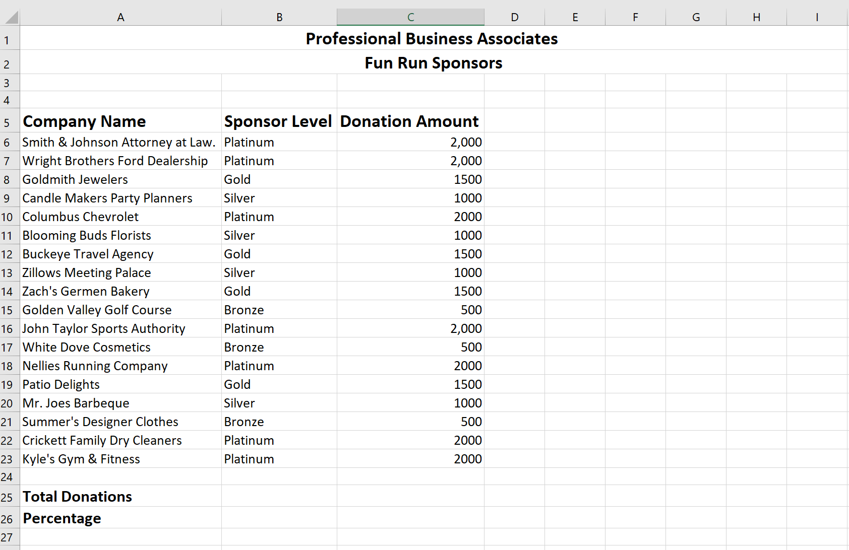

- In cell C6:C23, format the cells to currency, zero decimal places.
- In cell C25 create a formula to add up all of the donation amounts
- In Cell A26 Insert a new row
- In Cell A26 (new row) insert the text 2019 Total Donations
- In Cell C26 insert $23,250
- In cell C27, create a formula to determine the percentage of increase or decrease in donations from 2019 to 2020.
- Print Worksheet in Landscape
- In cell B5, create a filter of Silver sponsors. Print worksheet in Landscape
- In cell B5 create a filter of Bronze sponsors. Print worksheet in Landscape
- Print worksheet with Formulas formatting to fit 1 page in Landscape

JOB 5: Inventory Form

PBA is conducting the monthly inventory of all the office supplies in the storage room , Nancy Wells would like a new inventory form created to be used to keep a monthly account of the office supplies in the storage room. Be certain the form is user-friendly. Create a table that will allow all administrative assistants at PBA to help maintain accurate monthly inventory of office supplies so we are ordering the correct supplies that are depleted.
Print your form and give it to Nancy for approval. Make sure to include the titles Professional Business Associates and Office Supply Inventory Form at the top of your form.

All items listed should have a cell included on the form (and a cell for entering information):

- Product
- Calendars
- Correction Tape
- Correction Fluid
- Envelopes
- File Folders
- Glue
- Hole puncher
- Paper
- Paper Clips
- Pencils
- Pens
- Rulers
- Scissors
- Stamps
- Tape
- Staplers
- Staples
- Printer cartridges
- Toners
- Batteries
- Hand Sanitizer
- Highlighters
- No. of Items
- Date of inventory
- Supplier
- Signature for Verification

